
XEPHO VIDEO COMPOSITION ENGINE
Technical Architecture, Product Requirements & Cost-Control Specification
How Xepho should create premium learning video without paying premium generative-video prices for every second

Document | Value
Audience | Developers, new joiners, Technical Lead, DevOps, QA, UI/UX, Product and Architecture
Scope | Xepho AI/video lesson generation and directly related media, orchestration, safety, accessibility, cost and delivery controls
Status | Proposed target architecture and developer implementation specification
Version | 2.0 — gap-complete update
Date | August 2026
Source baseline | Updates and supersedes the engineering direction in Xepho_Video_Generation_Cost_Reduction.docx

ONE SENTENCE TO REMEMBER
Xepho should buy only the few seconds where new generative motion materially improves learning. Everything else should be reused, transformed, deterministically rendered, composited or lip-synced.

Contents and How to Use This Report
This report is intentionally written for developers who may be new to Xepho. Read Sections 1–6 first to understand the product and architectural intent; Sections 7–22 define the components; Sections 23–34 define governance and operations; Sections 35–42 define delivery, testing, immediate implementation and developer release requirements.
- 1. Executive direction and business constraint
- 2. What is wrong with full-duration generative video
- 3. Design principles and target economics
- 4. Target architecture
- 5. End-to-end lesson lifecycle
- 6. Decision hierarchy: reuse → transform → render → generate
- 7. AI Lesson Director
- 8. Scene Decision Matrix and risk classes
- 9. Scene Graph
- 10. Scene DSL and deterministic renderer
- 11. Scene taxonomy and template library
- 12. Presenter Engine
- 13. Narration, TTS and master clock
- 14. Asset Engine, semantic reuse and Course Asset Packs
- 15. Still-image-to-motion pipeline
- 16. Specialist deterministic renderers
- 17. Software demonstration engine
- 18. Generative Video Engine
- 19. Provider abstraction, capability registry and routing
- 20. Draft, resolution and upscaling strategy
- 21. Cost Governor and complete cost ledger
- 22. Job orchestration, queues and parallelism
- 23. Failure, retry, fallback and atomic publishing
- 24. Quality Control Engine
- 25. Safety-critical and regulated learning
- 26. Accessibility by design
- 27. Localisation and multilingual retiming
- 28. Interactive assessments inside video journeys
- 29. Adaptive video delivery and low-bandwidth support
- 30. Creator storyboard/editor UX
- 31. Asset rights, consent, provenance and privacy
- 32. Multi-tenancy and asset scope
- 33. Security controls
- 34. Observability and operational dashboards
- 35. Unit economics and subscription guardrails
- 36. Benchmark and Golden Video Test Suite
- 37. CI/CD, versioning and regression gates
- 38. Recommended data model
- 39. API/service contracts
- 40. Immediate build acceptance criteria
- 41. Immediate implementation mandate — parallel execution tracks
- 42. Developer backlog, DoD and decisions required
- Appendices: examples, glossary and checklists

1. Executive Direction and Business Constraint
Video is a major part of Xepho’s product proposition. The economic model therefore cannot allow a customer paying roughly $100 per month to trigger hundreds of dollars of variable video-generation cost. The system must be designed so that high visual quality is achieved primarily through composition intelligence, not through purchasing every second from a text-to-video model.
PRIMARY PRODUCT REQUIREMENT
A standard Xepho lesson may run for up to approximately five minutes, but the default pipeline should target no more than about 10% newly generated video footage unless the learning objective genuinely requires more.

Metric | Engineering target | Why it matters
Maximum standard lesson length | ≈5 minutes | Provides a clear production envelope while supporting short-form pedagogy.
Standard generative-video ratio | ≤10% of final runtime | Breaks the direct relationship between lesson duration and generative-video spend.
Initial fully loaded marginal COGS target | ≤$4 per published 5-minute lesson | Commercially workable starting envelope; must be proven with telemetry.
Optimised marginal COGS target | ≤$2 per published lesson | Supports stronger gross margin and larger included usage.
Longer-term ambition | Approach <$1 where technically/quality feasible | Not a promise; a direction enabled by reuse, self-hosting and deterministic rendering.
Missing teaching content after generation failure | 0% | Visual failure must never remove the learning point.
Paid-call ledger coverage | 100% | No invisible COGS.

All dollar figures in this report are engineering modelling targets inherited from Xepho’s cost-reduction work. They are not customer pricing commitments and must be confirmed by benchmark telemetry before commercial use.

1.1 What success looks like
- A learner receives a polished, coherent five-minute multimedia lesson that looks intentionally produced rather than assembled from random AI clips.
- Only motion-critical scenes invoke expensive generative video automatically.
- Presenter identity, voice, typography, branding and instructional structure stay consistent across the course.
- Every paid operation is attributable to tenant → course → lesson → scene → generation attempt.
- A change to one sentence regenerates only affected assets, not the whole lesson.
- If a provider fails or a clip is rejected, the lesson degrades gracefully to a cheaper visual treatment while preserving narration and teaching content.
- The system can change providers without rewriting lesson logic.

2. Why Full-Duration Generative Video Is the Wrong Default
The existing cost baseline models a provider charging $0.16 for every finished second. At that rate, a 300-second lesson incurs roughly $48 of generated-picture cost before TTS, lip-sync, retries, rendering and other variable operations. The previous cost-reduction document correctly identified the generated picture as the dominant cost driver.
Approach | Generated seconds in a 5-min lesson | Indicative picture cost at $0.16/s | Architectural consequence
Generate everything | 300 s | $48.00 | Cost scales almost linearly with lesson duration.
Loop some static footage | Lower but still large | Still material | Useful optimisation but does not change the model.
Composition Engine default | ≈10–30 s | $1.60–$4.80 before routing optimisation | Expensive generation becomes a minority ingredient.

KEY SHIFT
Do not optimise only the price per generated second. First minimise the number of seconds that need generation at all; then optimise model, retries, resolution and GPU economics.

3. Design Principles and Target Economics
Principle | Developer interpretation
P1 — Pedagogy before spectacle | Choose the visual treatment that best teaches the learning objective, not the most cinematic treatment.
P2 — Reuse before generation | Search exact and semantic asset libraries before any new media call.
P3 — Transform before generation | Crop, reframe, animate, recolour, composite, extend or annotate an existing asset before generating a new one.
P4 — Render what code can render | Text, formulas, diagrams, charts, timelines, quizzes and software UI should be deterministic.
P5 — Presenter is an asset | A presenter identity should be reusable and animated/lip-synced, not regenerated from text for every scene.
P6 — Buy the verb, render the nouns | For demonstrations, pay only for the seconds where meaningful physical motion occurs; render setup/settle/context cheaply.
P7 — Audio is the master clock | Generate narration and timings first so visual durations are exact.
P8 — Failure changes richness, not content | Teaching and narration survive every fallback.
P9 — Cost is a runtime policy | Every paid call requires estimation, budget reservation, actual-cost recording and reconciliation.
P10 — Provider neutrality | Lesson logic targets capabilities, not vendor names.
P11 — Safety overrides cost | High-risk procedural scenes may require verified assets or human approval even if AI generation is cheap.
P12 — Accessibility is an output requirement | Captions, transcripts, adaptive delivery and accessible interactions are produced from the same scene graph.

4. Target Architecture
The Composition Engine is an orchestration and rendering architecture, not one model. Xepho owns the scene plan, asset selection, timing, composition, quality gate and cost policy. External providers supply specialist outputs only when needed.
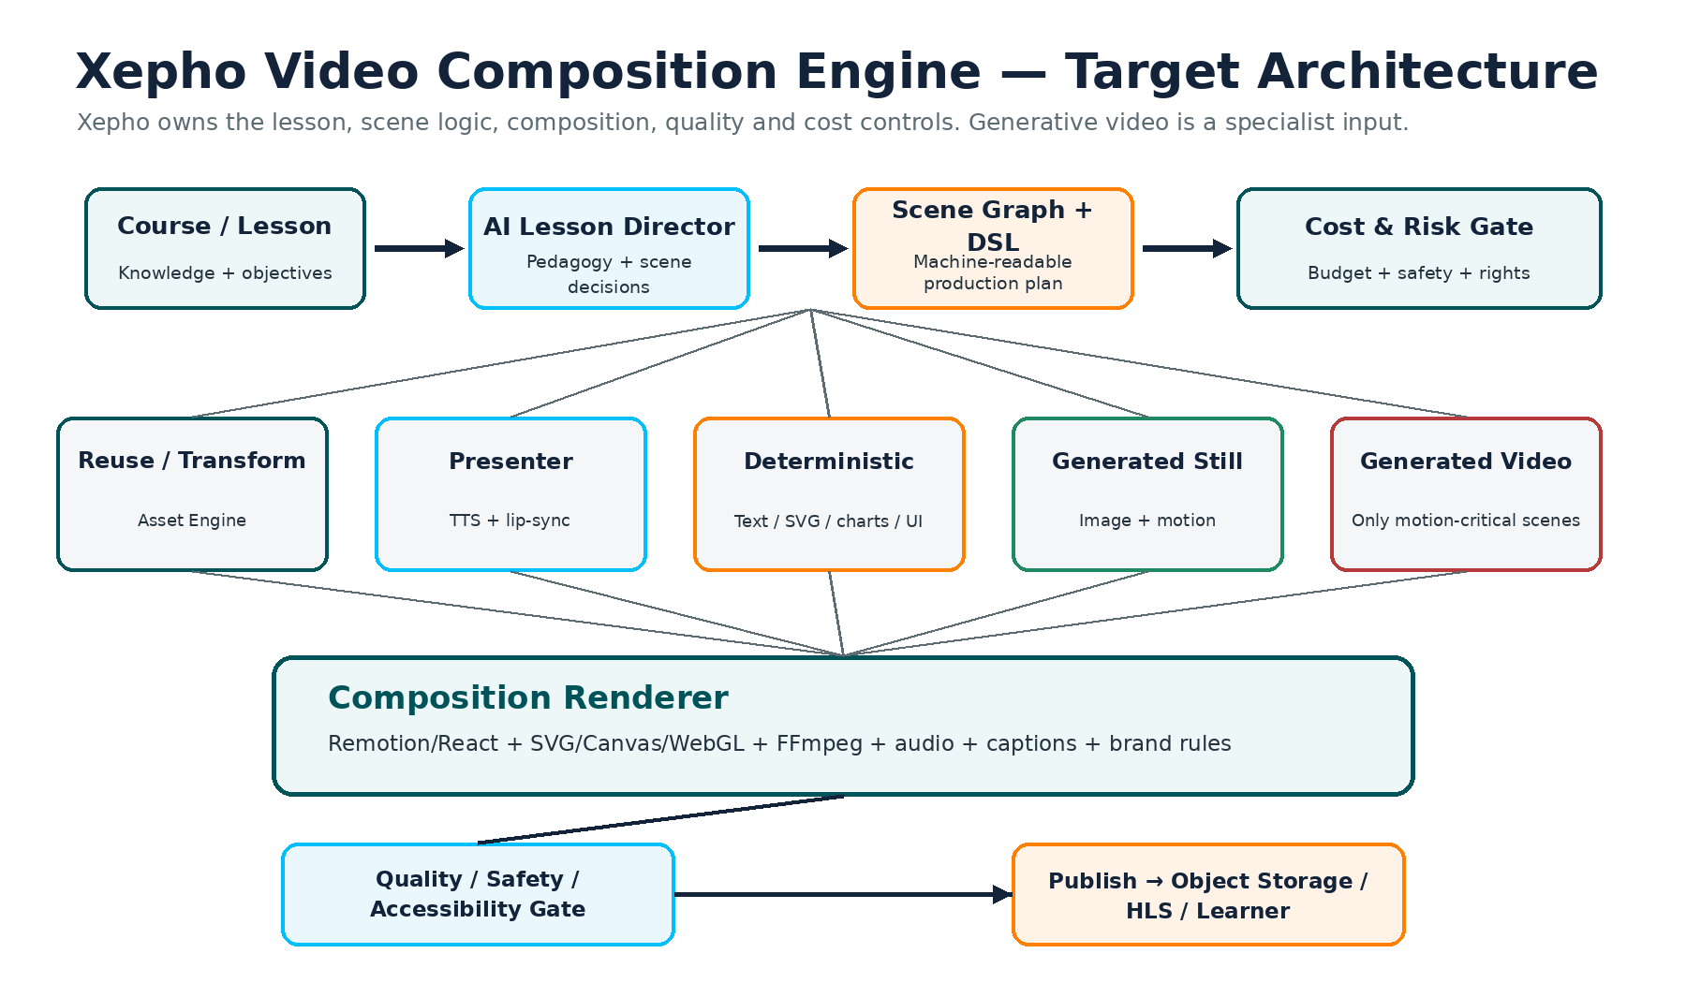
Subsystem | Primary responsibility | Must not do
AI Lesson Director | Interpret objectives; propose scenes, treatments and narration. | Directly call a provider without passing cost/risk gates.
Scene Graph + DSL | Represent the lesson and exact render instructions. | Collapse source-of-truth into only an MP4.
Asset Engine | Find, scope, transform, store and reuse assets. | Leak private tenant assets into global reuse.
Presenter Engine | Reusable identity + voice + lip/facial/gesture variation. | Regenerate a new person in each scene.
Deterministic Renderer | Create exact text, diagrams, charts, UI and motion graphics. | Rely on generative models for exact instructional text.
Generative Media Engine | Produce genuine motion/imagery where required. | Generate whole lessons by default.
Provider Router | Select eligible provider/model by capability, quality, cost and health. | Pick only by sticker price.
Cost Governor | Estimate, reserve, cap, record and reconcile spend. | Permit unmetered retries.
Quality/Safety Gate | Validate educational, factual, visual, technical and rights requirements. | Publish merely because a file was returned.
Renderer/Publisher | Compose, encode and atomically publish final outputs. | Replace the old live version until new version passes.

5. End-to-End Lesson Lifecycle
- Creator starts from source content, a prompt, existing course material or Xepho zero-content course creation.
- Xepho derives learning objectives, lesson outline and narration draft.
- AI Lesson Director proposes a scene plan using the controlled taxonomy.
- Scene Decision Matrix assigns motion need, factual/safety criticality, realism, reuse potential and interaction value.
- Asset Engine searches exact hash cache, semantic tenant library, course assets and eligible Xepho global library.
- Cost Governor estimates proposed paid work and reserves budget.
- Creator may review/lock/change the storyboard before expensive generation.
- Narration is synthesised as a lesson-level master take (or policy-approved sections) and aligned to word timings.
- Independent image, video, diagram and presenter jobs execute in parallel.
- Each generated asset passes automated QC and risk policy; failures retry within bounded cost then downgrade.
- Composition Renderer builds scenes from DSL + assets + audio + brand rules.
- Final lesson passes accessibility, technical, safety and content integrity checks.
- Output is transcoded to delivery renditions and atomically published; source scene graph and assets remain editable.
- Telemetry records cost, latency, quality, reuse, engagement and later learning outcomes.

6. Decision Hierarchy: Reuse → Transform → Render → Generate
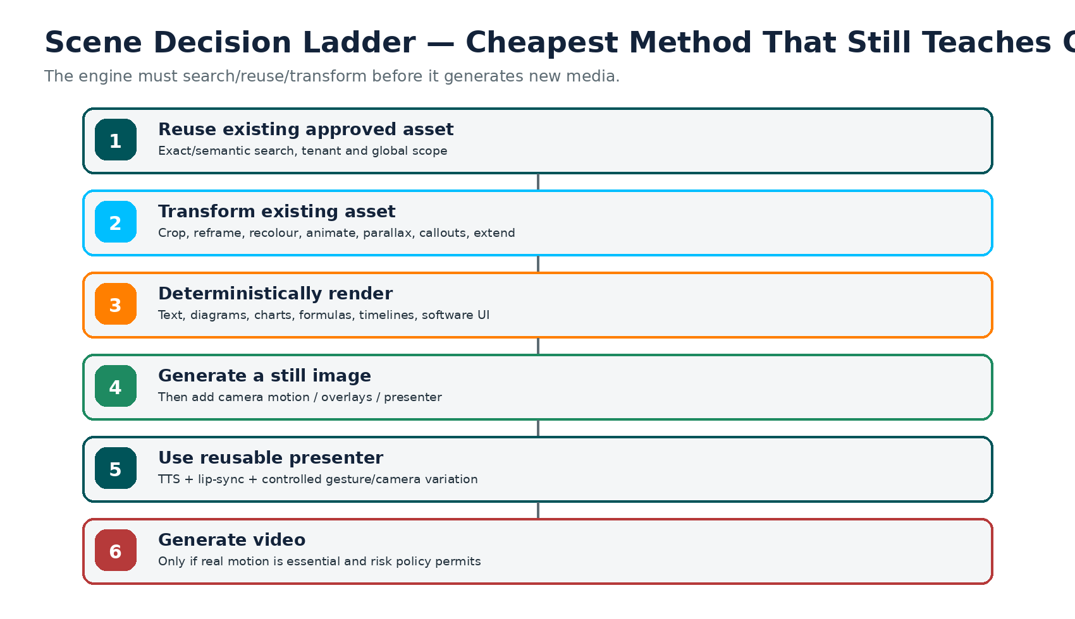
MANDATORY SEARCH RULE
Every new media request must pass through asset search. A developer must not call image/video generation directly from a scene handler.

7. AI Lesson Director
The AI Lesson Director produces an instructional production plan. It should be deterministic in contract even if the internal reasoning uses an LLM: input and output schemas are versioned, validated and testable.

7.1 Required inputs
Input | Examples / notes
Lesson objective | What the learner must know/do by the end.
Source content | Uploaded material or AI-generated course content.
Audience / level | Beginner, professional, apprentice, etc.
Mode / tenant policies | Standard/Enhanced/Cinematic; regulated content controls.
Available assets | Course pack, tenant library, global eligible assets.
Presenter configuration | Selected presenter/voice or none.
Brand system | Colours, logo, typography, visual density.
Time envelope | Target duration and maximum lesson duration.
Cost envelope | Scene and lesson caps.
Accessibility requirements | Caption language, transcript, audio description/reduced motion policy.

7.2 Required output contract
LessonProductionPlan
lesson_id
target_duration
narration_script
scenes[]
scene_id
purpose
learning_objective_ref
proposed_scene_type
visual_necessity
factual_criticality
safety_risk
realism_requirement
interactivity_value
reuse_potential
preferred_assets[]
generation_required
fallback_chain[]
estimated_cost_budget
plan_version
prompt_template_version

7.3 Guardrails
- The Lesson Director may recommend generated video but cannot bypass safety or budget policy.
- Critical wording, formulas, code, assessment text and regulatory instructions must be rendered from source truth, not generated inside imagery.
- Every scene must cite the learning objective or teaching purpose it serves; purely decorative scenes must be explicitly identified.
- If a scene has no pedagogical purpose, the system should consider removing it rather than paying to decorate the lesson.

8. Scene Decision Matrix and Risk Classes
Replace the single Visual Necessity score as the only decision variable. Keep it, but add dimensions that distinguish “motion is useful” from “AI may safely invent this motion.”
Dimension | 0 / low | 5 / high | Used for
Motion necessity | Static is sufficient | Movement is essential | Whether video/animation is required.
Factual criticality | Decorative/context | Exact sequence/detail matters | QC strictness and verified source preference.
Safety risk | No consequence | Could cause injury/harm | Human approval and generation restrictions.
Realism requirement | Abstract diagram adequate | Photorealistic context essential | Scene class/model selection.
Presenter value | No human explanation needed | Human explanation materially helps | Presenter choice.
Reuse potential | Highly unique | Generic/recurrent | Whether to invest in a reusable premium asset.
Interactivity value | Passive viewing fine | Learner action is better | Video vs interactive Xepho component.
Generation confidence | Models frequently fail | Known reliable route | Whether automatic generation is permitted.

8.1 Risk classes
Class | Example | Default policy
R0 Decorative | Office ambience, abstract background | AI freely allowed within brand/moderation policy.
R1 Conceptual | Solar energy visualisation | AI allowed; automated QC.
R2 Demonstrative | Basic non-safety software/task example | AI allowed after benchmark; factual check.
R3 Procedural | Assembly sequence / equipment use | Generated asset must pass detailed sequence validation; human/SME approval configurable.
R4 Safety-critical | First aid, electrical isolation, machinery safety | Verified/approved media preferred; SME approval mandatory before publish.
R5 Regulated / high consequence | Clinical procedure, formal assessment evidence | Tightly controlled sources; generative demonstration normally prohibited unless governance explicitly approves.

9. Scene Graph — The Editable Source of Truth
A lesson must be stored as structured scenes plus references to assets and timings. The final MP4/HLS rendition is a publication artefact, not the editable source of truth.
scene {
id, lesson_id, order, version
scene_type
learning_objective_ref
narration_text
narration_start_ms, narration_end_ms
planned_duration_ms
decision_scores { motion, factual, safety, realism, presenter, reuse, interaction, confidence }
template_id, template_version
asset_refs[]
generation_policy { required, budget, providers_allowed, max_attempts }
fallback_chain[]
brand_overrides
accessibility { alt_summary, audio_description, reduced_motion }
status
}

9.1 Why this matters
- Delta regeneration: one edited scene can be rebuilt independently.
- Localisation: narration/text/timing can change while visual assets remain reusable.
- Provider switching: a generated clip is replaceable without changing lesson semantics.
- Accessibility: transcript and scene descriptions can be derived directly.
- Interactive events: video can pause at a scene boundary and hand control to a Xepho quiz/activity.
- Auditability: a published lesson can be traced back to exact model, prompt, template and asset versions.

10. Scene DSL and Deterministic Renderer
The Scene DSL (domain-specific language) is the machine-readable render instruction for non-generative scenes. It turns semantic teaching intent into reproducible frames.

10.1 Example DSL
{
"type": "process_flow",
"title": "How solar energy reaches the home",
"layout": "horizontal",
"nodes": [
{"id":"panel","label":"Solar panel","icon":"solar_panel"},
{"id":"inverter","label":"Inverter","icon":"inverter"},
{"id":"home","label":"Home","icon":"house"}
],
"edges": [
{"from":"panel","to":"inverter"},
{"from":"inverter","to":"home"}
],
"timeline": [
{"at_ms":0,"action":"show","target":"panel"},
{"at_ms":3200,"action":"highlight","target":"inverter"},
{"at_ms":6500,"action":"highlight","target":"home"}
]
}

10.2 Recommended rendering stack
Layer | Recommended role
React / Remotion | Scene composition, timeline and reusable components.
HTML/CSS | Typography, cards, tables, layout and branded UI-like scenes.
SVG | Diagrams, arrows, icons, callouts and exact scalable graphics.
Canvas/WebGL/Three.js | Complex movement, parallax, simulation and 3D-like visuals where justified.
Lottie | Reusable lightweight motion assets where suitable.
FFmpeg | Audio mix, transitions, encoding, concatenation, HLS preparation and final packaging.

IMPORTANT
“Xepho renders it” is not zero engineering work. The deterministic renderer is a core product subsystem and should be treated as reusable platform IP, with versioned templates, automated visual regression tests and brand-safe constraints.

11. Scene Taxonomy and Template Library
Family | Initial scene types | Notes
Presenter | P01 Full-screen; P02 left/content right; P03 right/content left; P04 picture-in-picture; P05 presenter + quote; P06 presenter + diagram | Variation prevents repetitive avatar footage.
Teaching | T01 definition; T02 key points; T03 process; T04 timeline; T05 comparison; T06 cause/effect; T07 before/after; T08 hierarchy; T09 formula; T10 worked example; T11 chart/data; T12 map | All exact text and structure rendered by Xepho.
Image | I01 full image; I02 image + callouts; I03 image + presenter; I04 parallax; I05 image sequence | Prefer motion from stills before video generation.
Assessment | Q01 MCQ intro; Q02 true/false intro; Q03 select image; Q04 identify error; Q05 pause/think; Q06 answer explanation | The real answer interaction should normally stay as an LMS object.
Demonstration | D01 physical demo; D02 equipment; D03 workplace scenario; D04 lab procedure; D05 practical skill; D06 environment; D07 software demo | D01–D06 may use generated/verified video; D07 should normally use real deterministic screen capture.
Recap / transition | R01 section recap; R02 summary map; R03 chapter transition; R04 glossary recap | Template-heavy and cheap.

12. Presenter Engine
The presenter must be modelled as a reusable controlled asset package, not a prompt that recreates a human on every scene.
Presenter package element | Requirement
Identity references | Approved images/video or model representation; stable identity identifier.
Voice profile | Approved voice; language variants; cloning consent metadata if applicable.
Camera profiles | Close-up, medium, left/right framing; transparent/compositable backgrounds where possible.
Pose/gesture library | Neutral, emphasis, open-hand, point-left/right, listening; avoid repetitive loops.
Expression controls | Neutral, positive, serious/attention; bounded rather than unconstrained generation.
Lip/facial animation | Replace narration cheaply without rebuilding the entire person.
Wardrobe / brand constraints | Persist at presenter/course/tenant level.
Consent and deletion | Explicit governance for real-person likeness and voice.
Reuse scope | Xepho global / tenant / course / creator-private / restricted.

12.1 Avoiding the “five-second loop” look
- Use multiple approved motion segments/gesture states and switch only at natural phrase boundaries.
- Vary camera framing and composition rather than regenerating identity.
- Use presenter only when it improves explanation; do not fill every quiet visual moment with a talking head.
- Maintain temporal continuity within a scene and visual identity continuity across the course.
- Benchmark lip-sync, eye movement, blinking, hand movement and expression separately.

13. Narration, TTS and the Master Clock
Narration is the timing source for the visual timeline. The previous document’s one-voice-per-lesson concept should remain, subject to provider limits and editability requirements.
- Finalise lesson narration text before expensive visuals.
- Synthesise one continuous lesson take where practical to maximise voice consistency and minimise minimum-call billing.
- Obtain word- or phoneme-level timestamps from the TTS provider or forced alignment.
- Derive scene start/end from semantic phrase boundaries, not arbitrary fixed clip lengths.
- Generate/render visuals to those exact durations.
- When a sentence is edited, regenerate only the affected audio region if seamless splicing is validated; otherwise regenerate the full low-cost TTS track while reusing expensive visuals.
Audio artefact | Store? | Why
Narration script version | Yes | Audit, localisation and regeneration.
Master narration WAV/FLAC | Yes | High-quality source for composition.
Word/phoneme timestamps | Yes | Captions and visual synchronisation.
Scene audio slices | Cache | Fast scene-level render; derivable from master.
Final mixed audio | Yes | Publication source.

14. Asset Engine, Semantic Reuse and Course Asset Packs
Exact hashing prevents duplicate calls, but a genuine reuse moat also requires semantic search. Two prompts can describe the same reusable action with different words.
Asset lookup order
1. Exact content hash
2. Course Asset Pack
3. Tenant semantic library
4. Creator/private eligible library
5. Xepho licensed global library
6. Transform an existing close match
7. Generate new asset

Asset metadata | Examples
Semantic content | objects, actions, environment, equipment, people, concept, topic
Visual attributes | camera angle, framing, style, lighting, resolution, duration
Learning attributes | scene types supported, risk class, factual validation status
Generation provenance | provider, model, version, prompt, seed/reference, date
Rights / scope | licence, consent, tenant scope, reuse scope, expiry
Cost | generation cost, accumulated reuse count, avoided-cost estimate
Quality | QC status, quality score, rejection reasons

14.1 Course Asset Pack
- Presenter and voice configuration.
- Course intro/outro and transition system.
- Brand palette and typography.
- Common backgrounds and environments.
- Core diagrams/icons/illustrations.
- Approved recurring demonstration clips.
- Course glossary/terminology style.
- Music/sound assets where licensed and appropriate.
STRATEGIC METRIC
A later lesson in a course should normally cost less to produce than the first because it can reuse presenter, visual style, diagrams, backgrounds and demonstrations.

15. Still-Image-to-Motion Pipeline
A high-quality still can often support 15–30 seconds of visual storytelling when combined with deterministic movement and overlays. This should be a first-class scene pipeline, not an afterthought.
- Search for an existing suitable image; generate a new still only if needed.
- Create/estimate a focal map and optional depth segmentation.
- Choose a camera treatment: slow pan, push-in, pull-out, crop reveal, parallax or focus transition.
- Overlay exact labels, callouts, highlights and presenter windows on narration timings.
- Use multiple crops of the same source image to create shot variation without buying new media.
- Apply subtle movement only; avoid fake motion that distracts from teaching.
“BUY THE VERB, RENDER THE NOUNS”
For a demonstration, consider generating only the 2–5 seconds in which meaningful action occurs. Use stills or deterministic shots for setup, context and settle frames.

16. Specialist Deterministic Renderers
Generic motion graphics should not be the only cheap alternative. Domain-specific deterministic renderers can be more accurate and more educational than photorealistic generated video.
Learning content | Suggested deterministic technology / approach | Why
Mathematics | LaTeX / KaTeX / MathJax + animated highlights | Exact formulas and symbols.
Process / flow | Mermaid/custom graph layout + SVG | Correct structure and editable nodes.
Charts / data | Vega/ECharts/D3 or equivalent | Data-driven, exact values.
Code | Syntax highlighter + line-by-line focus | Exact source code; no hallucinated text.
Software UI | Real browser capture via Playwright/Puppeteer | Accurate interface demonstration.
Maps | Map renderer + animated layers | Geographically controlled output.
Timelines | Xepho timeline components | Consistent chronology and branding.
Org/hierarchy | Graph/tree layout | Readable organisational structures.
Science diagrams | Curated SVG libraries / structured models | Factual accuracy and reuse.
Tables / comparisons | HTML/CSS render components | Precise wording and accessibility.

17. Software Demonstration Engine
Software training should usually show the real interface rather than an AI-invented imitation. This can be automated and remains far cheaper and more accurate than generative video.
Instruction / scripted task
↓
Sandbox application or deterministic fixture
↓
Playwright / browser automation
↓
Screen capture
↓
Xepho cursor + zoom + callouts + narration
↓
Software demonstration scene

- Use test/sandbox accounts and non-sensitive data.
- Anchor annotations to known UI elements so callouts remain accurate.
- Version fixtures against application releases; flag stale screenshots/flows.
- For third-party software, respect licensing and access restrictions.
- If automation fails, fall back to approved static screenshots + cursor/callout animation rather than generative imitation.

18. Generative Video Engine — Special-Effects Service
Generative video is reserved for scenes where new motion materially improves understanding and the risk policy permits synthetic footage.
Good use | Poor default use
Physical action that must be seen | Definitions or quotes
Environment or scenario B-roll | Slide-like content
Machinery / object movement after safety review | Exact code, formulas or UI
Conceptual cinematic visualisation | Presenter narration that can be lip-synced
Premium hero/opening footage | Quizzes/assessment text
Novel demonstration with no reusable/recorded asset | Anything already available in the asset library

18.1 Generated seconds policy
Mode | Target generative-video ratio | Intended use
Standard | 0–10% | Default high-volume subscription mode.
Enhanced | 10–20% | More practical demonstrations / richer scenarios.
Cinematic | 20–40% | Premium content only; explicit higher credit/cost policy.
Safety / regulated | Policy-controlled | Ratio is irrelevant; verified correctness governs.

19. Provider Abstraction, Capability Registry and Routing
The application layer should request a capability, not a provider. The provider router filters eligible models and then ranks them using expected accepted cost, quality, latency, availability and policy.
VideoGenerationRequest {
scene_id
capability: image_to_video | text_to_video | reference_character | ...
duration_ms
aspect_ratio
min_resolution
reference_assets[]
required_consistency
risk_class
max_cost
max_latency
commercial_use_required=true
watermark_allowed=false
}

Registry field | Examples / use
Capabilities | text-to-video, image-to-video, reference character, start/end frame, audio, camera control
Limits | max duration, resolutions, aspect ratios, concurrency, quotas
Commercial/policy | commercial rights, watermark, moderation, retention, regions
Economics | list cost, effective cost/accepted second, retry rate
Quality | prompt adherence, temporal consistency, hands/faces, scene-class scores
Operations | p50/p95 latency, failure rate, rate-limit rate, current health
Version | provider model/version and adapter version

19.1 Routing score
eligible = capability_match && policy_match && within_budget
expected_cost = list_cost / max(first_pass_acceptance_probability, floor)
score = quality_weight*quality
- cost_weight*expected_cost
- latency_weight*p95_latency
- reliability_weight*failure_rate
+ reuse_bonus / preferred-provider adjustments

DO NOT ROUTE ON STICKER PRICE
A $0.05/s model needing two attempts can be more expensive than a $0.07/s model that passes first time. Track cost per accepted second/scene.

20. Draft, Resolution and Upscaling Strategy
Draft-before-final and low-resolution generation can reduce cost, but both require quality gates. The draft must predict the final sufficiently well; the upscaler must preserve temporal consistency.
Draft method | Best use | Limitation
Storyboard still | Composition/framing | Does not validate motion.
First-frame generation | Subject/identity/style | Does not prove sequence.
Start + end frames | Intended transition | Intermediate motion still uncertain.
Low-res same-model preview | Best proxy for final | May still incur material cost.
Cheap alternate model | Rough concept | Poor correlation with premium provider may mislead.
Motion preview / short crop | Validate action verb | Only samples part of sequence.

20.1 Upscaling acceptance criteria
- Compare native 1080p generation against low-res + upscale for the same scene class.
- Score temporal flicker, face detail, hand/tool integrity, text/labels, edge shimmer and fine motion.
- Prefer video-super-resolution approaches when frame-by-frame image upscaling creates temporal instability.
- Never upscale critical fine-detail demonstrations merely to save cost if the result impairs teaching.

21. Cost Governor and Complete Cost Ledger
No paid operation may begin without cost estimation, budget reservation and a traceable job record. This closes the previously identified gap where material video/narration costs were not fully represented in the margin guard.
estimate → reserve → execute → record actual → reconcile → release unused reserve / alert variance

Ledger category | Examples
Planning | LLM lesson/scene planning, moderation/classification
Speech | TTS, forced alignment, voice-clone service
Presenter | avatar animation, lip-sync GPU/API
Image | image generation/editing/background removal/upscale
Video | draft generation, final generation, rejected attempts
QC | vision-model review, safety validation, human-review cost if modelled
Compute | GPU/CPU render, upscale, transcode
Delivery | object storage, requests, CDN/egress where charged
Failure | retries, abandoned jobs, timeout costs

21.1 Minimum cost fields
tenant_id · organisation_id · user_id · course_id · lesson_id · scene_id · job_id
provider · model · model_version · operation · input_units · output_units · duration_units
estimated_cost · reserved_cost · actual_cost · currency · retry_number · accepted_boolean
quality_score · created_at · completed_at

21.2 Budget hierarchy
Level | Example control
Scene | Max $0.80 for this demonstration.
Lesson | Max $3.50 variable production budget.
Course | Max $25 included generation budget.
Tenant/month | Subscription-level video COGS cap / included credits.
Platform/provider | Daily emergency cap and provider circuit breaker.

22. Job Orchestration, Queues and Parallelism
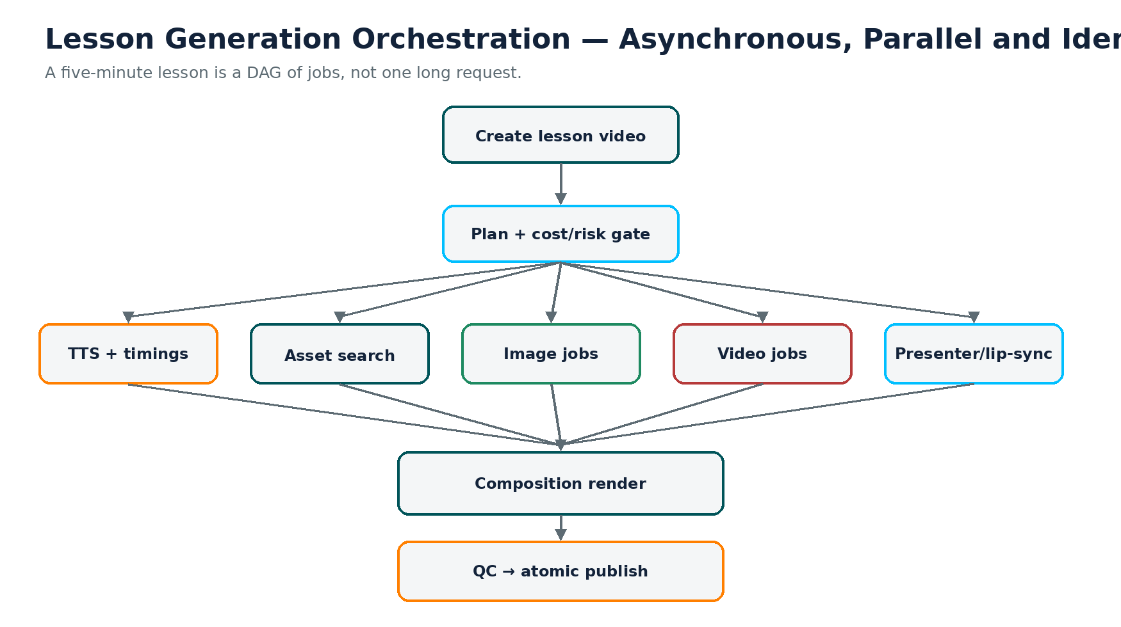
Orchestration requirement | Developer behaviour
Asynchronous jobs | Return a job ID; do not hold a browser request while generation runs.
DAG dependencies | TTS/timings gate duration-sensitive visuals; independent asset jobs run in parallel.
Idempotency | Replaying a message cannot accidentally trigger a second paid generation.
Checkpointing | Resume from completed stages rather than restart the lesson.
Cancellation | User cancellation stops eligible queued/running work and records sunk cost.
Dead-letter queue | Persistent failures leave the normal queue and become diagnosable.
Per-tenant fairness | One tenant cannot consume all workers/concurrency.
Rate-limit control | Respect provider quotas and back off without duplicate calls.
Circuit breaker | Temporarily remove unhealthy provider from routing.
Timeouts | Scene, provider-call and overall lesson timeouts are mandatory.
Priority | Preview/storyboard jobs can be lower cost/priority than publish jobs.

Suggested states
QUEUED → PLANNING → COST_RESERVED → AUDIO → ASSET_GENERATION → COMPOSITING → QC → ENCODING → PUBLISHING → COMPLETED
Failure branches: RETRY_WAIT | FALLBACK | HUMAN_REVIEW | FAILED | CANCELLED

23. Failure, Retry, Fallback and Atomic Publishing
A failed demonstration must never delete 25 seconds of teaching. The narration and learning objective are immutable; only the visual strategy changes.
Attempt | Action | Cost rule
0 | Try reusable/transform/deterministic alternative before generation. | Avoid paid call where possible.
1 | Primary provider with approved prompt/inputs. | Within reserved scene budget.
2 | Primary provider with bounded prompt correction or same-model low-cost retry. | Only if retry budget remains.
3 | Secondary provider with capability match. | Cost re-estimated/reserved.
Fallback | Generated still + motion or deterministic presenter/graphic. | Must always be available for non-safety-critical content.
Human review | For high-risk/regulated scenes or repeated QC failure. | Publishing blocked until resolved.

ATOMIC PUBLISHING
The existing live lesson remains available until the new lesson version has passed all required checks and the publication transaction succeeds. Never expose a half-rendered update.

24. Quality Control Engine
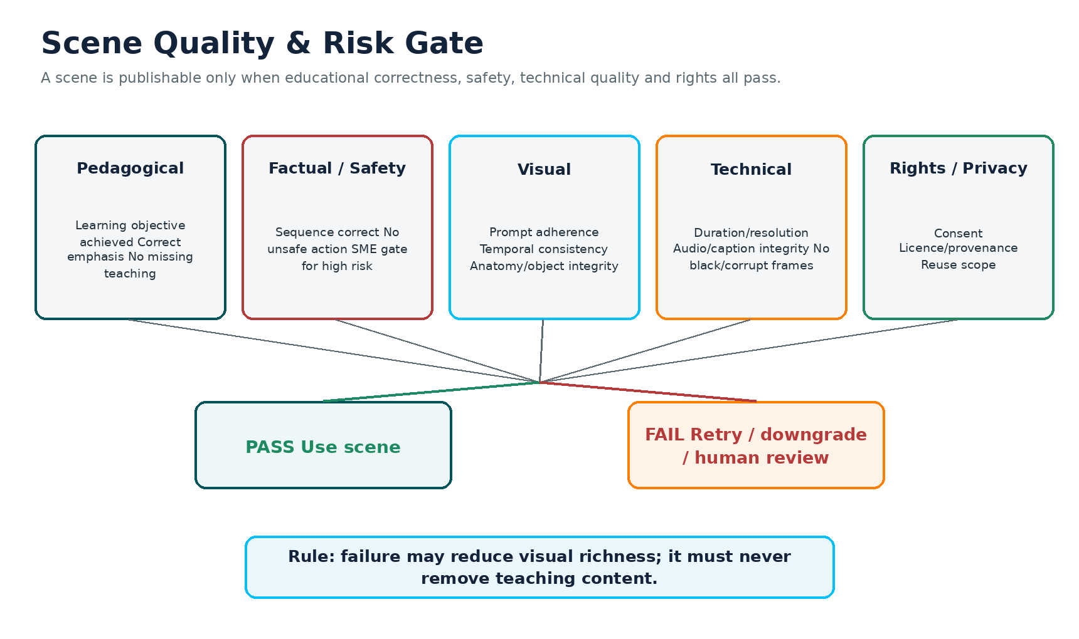
Quality dimension | Checks | Example action on failure
Pedagogical correctness | Scene serves objective; key idea preserved; no missing explanation | Fallback/replan scene.
Factual accuracy | Objects, sequence, labels and claims match source truth | Reject; deterministic/verified replacement.
Safety | PPE, sequence, dangerous action, prohibited behaviour | Block publish; SME review.
Prompt/action adherence | Requested subject/action/environment appears | Retry/re-route.
Temporal consistency | Identity/object stable through motion; no severe flicker | Retry/different model/native resolution.
Anatomy/object integrity | Hands, tools, machines, geometry plausible/correct | Reject or use verified asset.
Presenter consistency | Face, clothing, voice, framing match course profile | Regenerate presenter layer only.
Audio/lip-sync | No drift/clipping; speech intelligible | Re-run lip-sync/audio mix.
Technical | Duration, codec, resolution, corruption, black frames | Re-render/transcode.
Brand | Colours/logo/layout follow tenant rules | Re-render deterministic layers.
Accessibility | Captions/transcript/contrast/motion requirements pass | Block publish until fixed.
Rights/provenance | Consent/licence/reuse scope valid | Block asset use.

25. Safety-Critical and Regulated Learning
Photorealism is not evidence of correctness. Xepho must treat high-consequence demonstrations differently from decorative or conceptual content.
- R4/R5 scenes require a named approval policy before publication.
- Prefer customer/industry-approved reference footage, deterministic simulation or SME-approved assets for safety-critical steps.
- If AI-generated video is used, attach the generation provenance and approval record to the asset.
- Never allow a general visual-quality score to override a failed safety/factual check.
- For apprenticeship or competency evidence, generated media must never be confused with evidence of a learner actually performing a task.
Required record for high-risk scene | Example
Risk class | R4 Safety-critical
Authoritative source | Procedure/manual/version
Validation checklist | Step sequence, PPE, controls, prohibited actions
Reviewer | SME / authorised role
Decision | Approved / rejected / revision required
Approved asset version | Immutable asset/version ID
Expiry/review date | Re-review when procedure changes

26. Accessibility by Design
Accessibility must be generated from the scene graph rather than bolted onto the final MP4.
Capability | Requirement
Captions | Accurate, editable, timestamped; exported as WebVTT/SRT and available in player.
Transcript | Full text with scene/section structure; searchable where feasible.
Keyboard/player controls | Playback, seek, captions, speed and volume accessible by keyboard.
Screen-reader player semantics | Controls and interactive overlays use accessible HTML.
Contrast and type size | Template-level automated checks.
Flashing / rapid motion | Rule-based limits and QC detection.
Reduced-motion mode | Replace parallax/large animation with simpler transitions where policy/user preference requires.
Audio description | Support scene descriptions for content where key information is only visual.
Interactive quizzes | Accessible native LMS controls, not only text baked into frames.

VARK NOTE
Xepho’s Visual mode is video. Slide/read-write elements may be composed inside a video, but they should not be reclassified as Visual assets in the platform taxonomy; preserve the existing VARK distinction.

27. Localisation and Multilingual Retiming
Visual assets can often be reused across languages, but the timeline is not automatically language-agnostic. Different languages produce different spoken durations and text expansion.
- Translate/localise the narration and on-screen text from controlled source content.
- Generate new narration and obtain new word timings.
- Reconcile each scene duration against the new narration.
- Extend/reduce loops, camera moves, holds and presenter segments where possible without regenerating expensive footage.
- Re-cut or regenerate only a scene whose motion cannot be retimed acceptably.
- Re-render deterministic text/layout for the target language.
Localisation concern | Renderer requirement
Text expansion | Responsive layout, font scaling and overflow handling.
RTL languages | Direction-aware components and animation order.
CJK | Appropriate line breaking and typography.
Voice duration | Dynamic scene retiming and loop/hold strategy.
Terminology | Tenant/course glossary and protected terms.
Presenter voice | Same presenter identity can map to approved language voice profiles.

28. Interactive Assessments Inside Video Journeys
Do not bake every quiz into a passive video. Xepho can visually introduce a question, then pause and hand control to a real LMS assessment component.
Video timeline
↓ at event marker
PAUSE
↓
Xepho interactive question
├─ learner response recorded
├─ scoring / feedback
├─ analytics / competency mapping
└─ branching if configured
↓
RESUME video

- Keep question text/answers as structured assessment data.
- Render a non-interactive visual preview only where it improves flow.
- Resume at the correct scene/timestamp after interaction.
- Use the same event model for “pause and reflect”, external activity prompts and kinesthetic tasks.
- Preserve accessibility and audit records for attempts.

29. Adaptive Video Delivery and Low-Bandwidth Support
Generation resolution and learner delivery resolution are separate decisions. Produce a high-quality master, then create adaptive renditions for different devices and bandwidth conditions.
MASTER RENDER
├─ 1080p rendition
├─ 720p rendition
├─ 480p rendition
├─ 360p rendition
├─ audio-only
├─ WebVTT captions
└─ transcript

- Use HLS/DASH or an equivalent adaptive streaming approach where the platform stack supports it.
- Support resume/retry and efficient segment delivery for unstable networks.
- Consider controlled offline download/encrypted cached playback for target markets where connectivity is poor.
- Generate thumbnails/poster frames and avoid loading the highest rendition by default.
- Capture playback failures and effective bitrate as learner-experience telemetry.

30. Creator Storyboard and Editor UX
Autonomous generation should not remove creator control. A storyboard gate before expensive generation can prevent costly misinterpretation and gives creators a clear mental model of the lesson.
Creator action | System behaviour
Approve storyboard | Proceed to paid asset generation.
Change scene type | Re-cost and use the chosen template/pipeline.
Mark “must be video” | Allowed only if tenant/risk policy permits; cost estimate shown.
Mark “do not generate video” | Use reuse/still/deterministic/presenter alternatives.
Upload own media | Asset Engine ingests, validates, scopes and reuses it.
Lock an asset | Subsequent regeneration must preserve it.
Regenerate one scene | Only that scene and dependent outputs are invalidated.
Change presenter/voice | Recompute only presenter/audio-dependent scenes where possible.
Preview low-cost draft | Use cheap assets/resolution; do not publish as final unless it passes policy.

31. Asset Rights, Consent, Provenance and Privacy
Concern | Required platform behaviour
Likeness consent | Record explicit basis/consent for real-person avatar or voice cloning.
Deletion/revocation | Provide a method to disable/delete future use of a presenter/voice according to policy.
Copyright/licence | Record source, licence and permitted reuse scope for uploaded/stock/generated assets.
Provider retention/training | Review provider terms; store policy metadata and restrict providers where needed.
Provenance | Preserve model, prompt/reference, version, timestamps and approvals.
Tenant confidentiality | Private customer assets cannot silently enter global library.
Minors/sensitive identities | Use stricter consent and policy controls.
Synthetic disclosure | Support product/policy disclosure where required.

31.1 Asset reuse scopes
Scope | Who may reuse
Xepho Global | Eligible tenants, subject to licence/policy.
Tenant Global | Any authorised creator within the organisation.
Course | Only lessons in that course.
Creator Private | Only the owning creator.
Restricted | No reuse except the exact approved publication.
Licensed Stock | According to the recorded licence.

32. Multi-Tenancy and Asset Scope
Although this report is focused on video, every persistent media object and paid job must be tenant-aware because cost, privacy, rights and branding are tenant-specific.
tenant_id must propagate through:
production plan → scene → asset → generation job → provider attempt → cost entry → render job → video output → analytics

- Use signed/private object URLs rather than public buckets for tenant assets.
- Enforce tenant filters at repository/service level, not only in the UI.
- Global Xepho assets must be explicitly classified as globally reusable.
- Tenant brand settings must be applied by the deterministic renderer and versioned with the render.
- Cross-tenant semantic search must never expose private metadata or thumbnails.

33. Security Controls
Control area | Minimum requirement
Secrets | Provider API keys in managed secret storage; never source code/client.
Signed access | Private media URLs with bounded expiry/access policy.
Upload security | Type/size validation, malware scanning where applicable, metadata sanitisation.
Provider callbacks | Signed webhook validation/idempotency.
Encryption | In transit and at rest according to Xepho platform policy.
Audit | Record who generated, approved, replaced, published or deleted media.
Least privilege | Workers access only required buckets/queues/secrets.
PII minimisation | Do not send unnecessary learner/customer data to generation providers.
Retention | Temporary render intermediates automatically expire.

34. Observability and Operational Dashboards
Metric | Why it matters | Initial target / rule
Generative Video Ratio | Primary economic architecture metric | ≤10% Standard.
Fully loaded COGS / published lesson | True marginal economics | ≤$4 initial target; prove.
Cost / tenant / billing period | Protect subscription margin | Within plan/credit envelope.
Cost per accepted second | Captures retries/rejections | Optimise per scene class.
First-pass acceptance rate | Provider efficiency | Trend upward; route accordingly.
Retry/fallback rate | Quality/reliability | <10% retries as initial benchmark target where realistic.
Asset reuse rate | Compounding cost moat | ≥30% by later lessons; measure by course.
Scene generation latency p50/p95 | UX and provider health | Track by provider/model/class.
Overall lesson time p50/p95 | Creator experience | Set SLO after benchmark.
Ledger coverage | Financial accuracy | 100%.
QC failure reason distribution | Find weak models/templates | Review weekly.
Playback error/effective bitrate | Learner experience | Track by geography/device.
Learning outcomes by scene type | Long-term pedagogical optimisation | Correlate with quiz/completion, not just views.

35. Unit Economics and Subscription Guardrails
A low per-lesson cost is necessary but not sufficient. A $2 lesson still loses money if a $100/month tenant creates 100 lessons. The commercial guardrail must operate at subscription/tenant level as well as scene/lesson level.
Economic layer | What to calculate
Fixed platform cost | Base infrastructure and engineering overhead (not attributed per scene for runtime gating).
Variable media COGS | TTS + presenter + image + video + retries + QC + rendering + delivery.
Tenant monthly COGS | Sum of variable jobs plus attributable delivery/storage.
ARPU / contract value | Subscription + add-ons/credits.
Gross contribution | Revenue less variable COGS and defined service costs.
Included credits | Usage envelope priced to protect desired margin.
Overage/premium generation | Enhanced/Cinematic usage may consume more credits or require add-on.

COMMERCIAL RULE
Do not market unlimited high-cost AI video inside a fixed $100 plan until observed usage and COGS support it. Use included generation credits/allowances and mode-specific cost weights.

35.1 Fully loaded lesson cost template
Component | Measured value
Planning LLM | $...
TTS / alignment | $...
Presenter / lip-sync | $...
Images | $...
Video drafts | $...
Accepted generated video | $...
Rejected/retried video | $...
QC | $...
GPU/CPU render | $...
Storage/delivery | $...
Failed/abandoned job allocation | $...
TOTAL PUBLISHED LESSON | $...

36. Benchmark and Golden Video Test Suite
Cheap providers, draft routes and upscalers may enter production only after a fixed benchmark. Run the same benchmark whenever a provider, model, prompt template, presenter engine, renderer or upscaler changes materially.
Benchmark class | Test
Presenter continuity | Same presenter across multiple scenes/lessons
Hands/tool use | Fine hand motion and object contact
Machinery | Moving mechanical parts
Safety/PPE | Procedural correctness
Office/workplace | Natural environment
Software UI | Exact interface action
Code | Exact source code rendering
Maths | Formula accuracy
Chart/data | Exact numbers/labels
Lab procedure | Objects, glassware, sequence
Outdoor | Lighting/weather/identity
Fast motion | Temporal stability
Image-to-video | Reference adherence
Multilingual presenter | Lip-sync/voice across languages
RTL scene | Layout correctness
Upscaling | Temporal flicker/details
Long scene | Identity/object drift
Diversity | Different people/skin/hair/clothing without artefacts
Accessibility | Caption/contrast/reduced-motion
Low bandwidth | Adaptive rendition/player behaviour

36.1 Scorecard
Dimension | Suggested weighting / rule
Pedagogical correctness | 25%; hard fail if key teaching is wrong/missing.
Factual accuracy | 15%; hard fail where critical.
Safety | Hard gate for risk-class scenes; not averaged away.
Prompt/action adherence | 10%
Temporal consistency | 10%
Character consistency | 10%
Anatomy/object integrity | 10%
Visual quality | 5%
Audio/lip-sync | 5%
Brand/technical integrity | 5% combined or local policy
Cost per accepted second/scene | Economic comparison, not quality score.
First-pass acceptance | Operational comparison.

37. CI/CD, Versioning and Regression Gates
The earlier production failure where fixes existed but were not copied to live must not recur. Video-engine changes need the same immutable deployment discipline as the platform.
commit → CI tests → build immutable artefact → deploy DEV → integration tests → STAGING/UAT → Golden Video regression → approval → deploy PRODUCTION → monitor → rollback if needed

Versioned object | Why
Lesson Director prompt/template | LLM behaviour changes can alter scene plans.
Scene taxonomy / DSL schema | Renderer compatibility and migration.
Scene template | Visual regression and reproducibility.
Provider adapter | API behaviour/cost interpretation.
Provider model version | Quality may change independently of Xepho.
Presenter engine/model | Identity/lip-sync reproducibility.
Renderer build | Final visual output provenance.
QC rules/model | Why a scene passed/failed.
Brand configuration | Published appearance.

- Never manually copy fixed code to live as a normal deployment method.
- Run a small canary benchmark after production deploy before opening full generation volume.
- Use feature flags by tenant for new scene types/providers.
- Allow immediate provider/model disablement without application redeploy where practical.
- Keep rollback to the previous stable application/render version.

38. Recommended Data Model
Entity | Purpose
video_project | Top-level generation/edit project; tenant, course/lesson, state, mode, budget.
lesson_video_version | Immutable published/draft version and output references.
scene | Semantic scene, timings, decision scores, template, status.
scene_render_spec | DSL payload + renderer/template versions.
scene_template | Controlled template definition and supported parameters.
asset | Media source/master with scope, provenance, rights, quality.
asset_embedding | Semantic search representation/metadata.
course_asset_pack | Reusable collection for course.
presenter | Identity, consent, scope and style config.
voice_profile | Voice/provider/language/consent profile.
generation_job | Logical paid or compute task.
generation_attempt | Provider/model attempt; cost, latency, outcome.
provider | Vendor configuration and health.
provider_model | Capability registry record and current economics.
cost_entry | Actual/estimated spend attribution.
budget_reservation | Scene/lesson/tenant budget hold.
quality_result | Automated/manual QC results.
approval | SME/creator/safety approval record.
render_job | Composition/transcode job and versions.
video_output | Master and adaptive renditions.
interactive_event | Quiz/reflection/activity marker in timeline.
localisation_variant | Language-specific narration/text/timing data.
analytics_event | Generation/playback/learning telemetry link.

39. API and Service Contracts
Service | Illustrative contract
Lesson Director | planLesson(lessonId, policy) → LessonProductionPlan
Asset Search | findAssets(query, scope, policy) → ranked Asset[]
Asset Transform | transform(assetId, operations) → Asset
Provider Router | route(request) → ProviderRoute
Generation | submit(request, route) → jobId; getStatus(jobId); cancel(jobId)
Cost Governor | estimate(request); reserve(amount, scope); reconcile(jobId, actual)
QC | evaluate(asset/scene, policy) → QualityDecision
Presenter | synthesisePresenter(presenterId, audio, settings) → Asset
Render | renderScene(spec); renderLesson(version) → renderJobId
Publish | publishAtomically(lessonVideoVersion) → output manifest
Localise | createLanguageVariant(baseVersion, language) → draft variant
Analytics | recordGenerationEvent / recordPlaybackEvent

39.1 Idempotency
Every paid POST/submit operation should accept an idempotency key derived from the logical job/attempt. Repeated queue delivery or client retry must return the same job or safely refuse duplication rather than incur another charge.

40. Immediate Build — Acceptance Criteria
The team should treat the following as the release-critical baseline to be implemented immediately. This is not a staged MVP followed by deferred safety or production controls. Workstreams may execute in parallel, but customer-facing release must not bypass the mandatory cost, content-integrity, accessibility, safety, deployment, tenant-isolation and observability gates defined in this report. The scene library may begin with a controlled set of high-value templates, but the underlying architecture must be production-safe from the outset.
Area | Immediate release requirement
Scene intelligence | Scene Graph, richer Scene Decision Matrix, risk class, controlled scene taxonomy and Scene DSL must be implemented as the common contract.
Providers | TTS, presenter/lip-sync, image and generative-video routes must sit behind provider adapters; at least one validated fallback path must exist for any paid motion-critical route.
Renderer | Remotion/React + SVG/HTML + FFmpeg composition, with exact text, diagrams, charts, image-motion and core presenter layouts.
Asset Engine | Exact cache, metadata/semantic search, tenant/course scope controls, transformations and Course Asset Packs. Library search must occur before paid generation.
Cost & usage | Complete ledger plus estimate/reserve/execute/reconcile controls at scene, lesson and tenant level before any customer use.
Failure & publishing | Bounded retry, deterministic fallback, content preservation, scene-level recovery, timeouts and atomic publishing.
Jobs & orchestration | Asynchronous DAG/queue execution with idempotency, cancellation, concurrency limits, dead-letter handling and provider circuit breakers.
Accessibility & localisation | Captions, transcript, responsive/RTL layouts, language-aware retiming and an accessible interactive-event path.
Output & delivery | Master render plus agreed adaptive renditions (minimum 1080/720/480 or equivalent), object storage, signed delivery and low-bandwidth support.
QA, safety & deployment | Golden benchmark gate, content-integrity hard gate, R0–R5 risk policy, approval workflow, CI/CD, immutable deployment and rollback.

40.1 Benchmark success metrics
Metric | Immediate release target
Standard generative-video ratio | ≤10% average unless the learning objective and risk policy justify more.
Fully loaded variable cost | ≤$4 average per five-minute published lesson as the immediate engineering ceiling to validate; optimisation should drive lower.
Missing teaching due to generation failure | 0 — failure may reduce visual richness but never remove teaching content.
Paid-call ledger coverage | 100% of paid/compute operations attributable to tenant, course, lesson, scene and attempt.
Critical on-screen text accuracy | 100% for definitions, numbers, formulas, code, assessment content and regulated instructions.
Retry / accepted-cost control | Bounded retries; route decisions based on observed cost per accepted scene/second, not sticker price alone.
Asset reuse | Mandatory search-before-generate; reuse should increase across lessons and courses while respecting rights and tenant scope.
High-risk publish without required approval | 0.
Manual file-copy deployment to production | 0 — production promotion must be reproducible through CI/CD with rollback.

41. Immediate Implementation Mandate — Parallel Execution Tracks

Parallel Track A — Composition Core, Cost Control and Content Integrity
Workstream | Immediate deliverable | Release evidence
Architecture | Scene Graph v1, Scene DSL v1, service boundaries, decision matrix and risk classification. | A complete benchmark lesson can be represented, validated and regenerated from structured data end-to-end.
Cost & guardrails | Cost ledger, estimate/reserve/execute/reconcile flow, scene/lesson/tenant caps and retry budgets. | 100% of benchmark paid calls are attributed; forced overspend attempts are blocked or downgraded.
Deterministic renderer | Core Remotion/React templates, SVG/HTML components, animation primitives and FFmpeg composition. | Core non-generative scene types render consistently with exact text and brand rules.
Narration & master clock | Whole-lesson narration path, word timings, scene boundary derivation and caption timing. | Scene duration and visual events are driven from audio timings; no unnecessary paid video seconds are purchased.
Presenter Engine | Reusable presenter identity, voice/lip-sync path, camera/gesture variation and consent/scope metadata. | Presenter remains recognisably consistent across multiple scenes and lessons without identity regeneration.
Asset Intelligence | Exact deduplication, semantic/metadata search, transformation path and Course Asset Pack. | Every generation request proves library search first; reusable assets are recovered under correct tenant/licence scope.
Generative Media | Provider abstraction, capability registry, primary route and validated fallback for motion-critical generation. | Lesson logic contains no vendor-specific dependency; route can switch without changing lesson semantics.
Orchestration | Queue/DAG execution, parallel independent jobs, idempotency, cancellation, timeout and DLQ behaviour. | Duplicate requests cannot double-charge; forced worker/provider failures resume or fall back without restarting the lesson.
Failure & content integrity | Bounded retries, deterministic downgrade ladder, hard QC gates and atomic publish. | Forced failed demonstration still produces a complete lesson with all narration/teaching preserved.

Parallel Track B — Quality, Reuse and Learning Experience
Workstream | Immediate deliverable
Quality Control | Automated technical/visual checks, quality score, provider/model version capture and manual-review hooks for high-risk scenes.
Creator UX | Storyboard review, scene-type override, lock/replace/regenerate controls, upload-own-media, cost preview and approval before expensive generation where configured.
Accessibility | Captions, transcript, keyboard/player requirements, contrast/motion rules and accessible interactive-event behaviour generated from the scene graph.
Localisation | Language-specific narration/text variants, word timings, scene retiming, responsive text, RTL support and reuse of language-agnostic assets.
Interactive learning | Timeline event model that pauses video for real Xepho quizzes/reflections/activities so responses, analytics and competency evidence remain interactive.
Delivery quality | Adaptive renditions, audio-only/transcript alternatives, low-bandwidth playback, thumbnails and master-to-rendition packaging.
Safety & approvals | R0–R5 risk handling, SME/creator approval records, verified-media preference for high-consequence procedures and publish blocks where required.
Benchmark & learning loop | Golden Video suite covering faces, hands, machinery, software, STEM, maths/code, multilingual, upscaling and safety; capture quality, latency, cost and first-pass acceptance.

Parallel Track C — Production Safety, Operations and Commercial Control
Workstream | Immediate deliverable
Platform operations & CI/CD | Immutable/reproducible build promotion, automated tests, Golden Video regression gate, canary benchmark, rollback and tenant feature flags.
Tenant & commercial policy | Standard/Enhanced/Cinematic policy configuration where used, tenant budgets/credits, concurrency controls and subscription-level COGS guardrails.
Rights, consent & provenance | Asset provenance, reuse scope, licence/consent metadata, presenter/voice deletion controls and audit trail.
Provider reliability | Health monitoring, p50/p95 latency, first-pass acceptance, moderation/rate-limit telemetry, circuit breakers and rapid provider/model disablement.
Security & multi-tenancy | Tenant-scoped asset access, signed URLs, secrets management, private storage, provider credential isolation and cross-tenant access tests.
Economics | Observed fully loaded COGS by scene/lesson/course/tenant, cost-per-accepted-second/scene and plan-level usage envelope.
Observability | Dashboards/alerts for job state, failures, retries, provider health, render latency, cost variance, asset reuse and storage/delivery growth.
Customer-release gate | Controlled customer enablement only after all mandatory acceptance, safety, cost, quality, accessibility, deployment and recovery evidence passes.
Release rule: all three tracks are mandatory and should be staffed in parallel. There is no calendar-based sequencing in this specification. Delivery is exit-criteria-driven: a capability is complete only when its evidence is demonstrated, and the video engine is customer-ready only when the mandatory release gates across all tracks pass together.

42. Developer Backlog, Definition of Done and Decisions Required

42.1 Epics
Epic | Scope
E1 Scene Intelligence | Lesson Director, decision matrix, risk classification, taxonomy.
E2 Scene Graph & DSL | Schemas, validation, migration/versioning.
E3 Renderer | Templates, animation primitives, FFmpeg composition.
E4 Presenter | Reusable identity, voice, lip-sync, gesture/camera profiles.
E5 Asset Intelligence | Storage, exact cache, semantic search, transforms, Course Asset Packs.
E6 Generative Media | Image/video adapters, routing, draft/upscale.
E7 Cost & Usage | Ledger, budgets, reservations, credits, dashboards.
E8 Orchestration | Queues, DAG, retries, idempotency, cancellation, DLQ.
E9 QC & Safety | Automated QC, risk gates, approvals, atomic publishing.
E10 Accessibility & Localisation | Captions, transcript, retiming, RTL/responsive layouts.
E11 Interactive Video | Timeline events, quiz/activity pause/resume.
E12 Delivery | Object storage, adaptive streaming, renditions, low bandwidth.
E13 Platform Ops | Observability, CI/CD, model/provider version controls, feature flags.

42.2 Definition of Done for any new scene type
- Schema/DSL contract exists and is versioned.
- Creator preview/edit behaviour is defined.
- Cost estimate and ledger attribution are implemented.
- Fallback path exists and preserves learning content.
- Accessibility behaviour is defined.
- Localisation behaviour is defined.
- Tenant/asset scope rules are tested.
- Quality and risk policy is defined.
- Golden benchmark cases exist.
- Automated unit/integration/visual regression tests pass.
- Production observability metrics exist.
- Documentation for new joiners is updated.

42.3 Decisions the development team must return
- Confirm the Scene Graph and Scene DSL technology/schema approach.
- Confirm the deterministic rendering stack and deployment model.
- Propose the presenter implementation and explain identity/gesture/voice reuse.
- Propose asset semantic-search technology and scope enforcement.
- Propose the queue/orchestrator and idempotency strategy.
- List candidate providers by capability behind the abstraction; do not design the core around one vendor.
- Propose the cost-reservation/ledger implementation and how provider billing is reconciled.
- Define QC automation vs human review for R0–R5.
- Define adaptive video output and object-storage layout.
- Provide implementation ownership, engineering capacity, dependencies, technical unknowns and the benchmark execution plan. Return the concrete work allocation, parallel ownership and release evidence needed to complete the system immediately rather than a calendar roadmap.

Appendix A — Worked Five-Minute Lesson
Scene | Duration | Treatment | New generative video? | Notes
Introduction | 20 s | Reusable presenter | No | Course presenter + master narration.
Learning objective | 20 s | Presenter + exact rendered text | No | Text synced to words.
Photovoltaic principle | 30 s | Animated SVG diagram | No | Deterministic.
Technician installs panel | 12 s | Generated/verified demonstration | Yes | Motion-critical; risk class reviewed.
Panel construction | 35 s | Animated cross-section | No | Structured diagram.
DC electricity flow | 30 s | Animated process flow | No | Deterministic arrows/highlights.
Inverter demonstration | 10 s | Generated/verified demonstration | Yes | Could reuse approved library clip.
DC→AC explanation | 35 s | Presenter + waveform | No | Deterministic chart/animation.
Practical example | 25 s | Image + camera motion | No | Still-to-motion.
Knowledge check | 35 s | Video intro + interactive Xepho quiz | No | Video pauses for actual response.
Answer explanation | 25 s | Presenter + visual | No | May branch by answer.
Summary | 23 s | Animated recap | No | Reuses prior visual assets.

ECONOMIC RESULT
The learner experiences approximately 300 seconds of professionally composed multimedia, while only around 22 seconds (7.3%) require new generated footage in this example — and even those clips may be reusable or replaceable by verified assets.

Appendix B — Cost-Optimisation Ladder
- Ask whether the scene is necessary for the learning objective.
- Reuse an approved asset if one already exists.
- Transform/reframe/animate an existing asset.
- Deterministically render exact instructional content.
- Use a still image plus motion if realism is needed but movement is not instructional.
- Use a reusable presenter if human explanation is valuable.
- Generate only the smallest motion-critical portion of a demonstration.
- Route to the cheapest benchmarked provider/model that meets capability/quality/risk requirements.
- Use draft/final and lower-resolution/upscale only where benchmarked effective.
- Reuse the accepted asset across scene, lesson, course and eligible libraries.
- Regenerate only deltas on edits/localisation.
- Use self-hosted/serverless open models for suitable commodity workloads only when observed economics justify them.

Appendix C — New Joiner Glossary
Term | Meaning
Scene | One continuous section of a lesson with one primary visual treatment.
Scene Graph | Structured source representation of the lesson, not the rendered MP4.
Scene DSL | Machine-readable instructions telling the deterministic renderer what to draw and when.
Visual Necessity | How much a scene needs movement; one dimension of the wider decision matrix.
Risk Class | R0–R5 policy describing consequence/correctness requirements.
Deterministic rendering | Xepho creates exact visuals using code/templates rather than generative invention.
Asset | Reusable image, clip, audio, presenter segment, diagram or other media.
Course Asset Pack | Reusable media/style collection created once for a course.
Provider Router | Selects an eligible AI provider/model for a capability request.
Capability Registry | Live metadata describing what each provider/model can do and its economics/health.
Cost Governor | Estimates/reserves/caps/reconciles generation spend.
Cost Ledger | Row-level record of every paid/attributable operation.
Cost per accepted second | Total generation spend divided by footage actually approved/shipped.
Master Clock | Narration timing that controls scene durations and on-screen events.
Fallback | Alternative visual treatment when the preferred method fails/costs too much.
Delta regeneration | Rebuild only affected scene/assets after an edit.
Atomic publish | New lesson version becomes live only after complete successful validation.
Idempotency | Same logical job cannot charge/execute twice due to retries/message redelivery.
Adaptive rendition | Alternative resolution/bitrate of the same master for learner delivery.

Appendix D — Final Engineering Direction
THE DIRECTION
Xepho owns the lesson, pedagogy, scene logic, asset library, presenter system, rendering, cost controls, quality gates and learner experience. External generative-video providers are replaceable specialist suppliers used only for the few seconds where new motion adds enough educational value to justify the cost and risk.

The target is not a “cheaper AI video API integration”. The target is an intelligent educational media compiler: source knowledge → learning objective → scene decisions → reuse/transform/render/generate → composition → quality/safety/accessibility → adaptive learner experience → analytics → better future decisions.

